ASSIGNMENT 9

- Count the number of vowels in a string

// Count the number of vowels in a string
#include<iostream.h>
#include<conio.h>
#include<stdio.h>
main()
{
clrscr();
char sch[30];
cout<<"\n Enter your name ";
gets(sch);
for(int i=0,vwl=0;sch[i]!='\0';i++)
{
if(sch[i]=='a' || sch[i]=='e' || sch[i]=='i' || sch[i]=='o' || sch[i]=='u' || sch[i]=='A' || sch[i]=='E' || sch[i]=='I' || sch[i]=='O' || sch[i]=='U')
vwl++;
}
cout<<endl<<" The number of vowels in "<<sch<<" is "<<vwl;
getch();
}

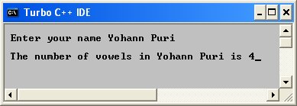

- Finding the length of the string

//Finding the length of the string
#include<iostream.h>
#include<conio.h>
#include<stdio.h>
main()
{
clrscr();
char sch[30];
cout<<"\n Enter your name ";
gets(sch);
for(int i=0;sch[i]!='\0';i++);
cout<<"\n The length of the string is "<<i;
getch();
}

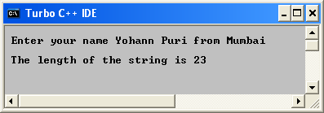

- Reversing a string
//Reversing a string
#include<iostream.h>
#include<conio.h>
#include<stdio.h>
main()
{
clrscr();
char sch[30];
cout<<"\n Enter your name ";
gets(sch);
for(int i=0;sch[i]!='\0';i++);
for(int j=i;j>=0;j--)
cout<<sch[j];
getch();
}

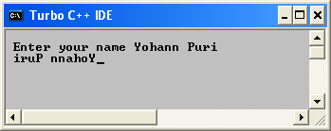

- Is the character contained in the string

//Is the character contained in the string
#include<iostream.h>
#include<conio.h>
#include<stdio.h>
main()
{
clrscr();
char a[25],ch;
int num=0;
cout<<"\n Enter a few words ";
gets(a);
cout<<"\n Enter a character ";
cin>>ch;
for(int i=0;a[i]!='\0';i++)
{
if(a[i]==ch)
{
cout<<"\n\n The character is present in the string";
num++;
}
}
if(num==0)
cout<<"\n\n The character is not present in the string ";

getch();
}

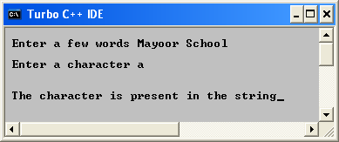

- Printing ASCII values

// Is the character contained in the string
#include<iostream.h>
#include<conio.h>
#include<stdio.h>
main()
{
clrscr();
cout<<"\n\n";
for(int i=1;i<256;i++)
{
if(i==26 || i>=7 && i<15)
continue;
cout<<i<<' '<<char(i)<<" ";
if(i==19 || i%10==0 && i>20 && i<100)
cout<<'\n';
if(i>90&& i%9==0)
cout<<'\n';
getch();
}

getch();
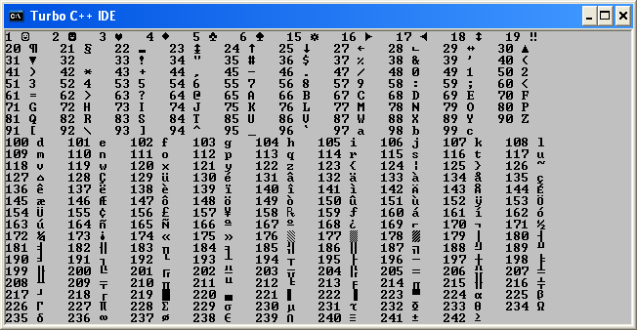
}

- Counting number of times a character is present

// Counting number of times a character is present
#include<iostream.h>
#include<conio.h>
#include<stdio.h>
main()
{
clrscr();
char a[25],ch;
int num=0;
cout<<"\n Enter a few words ";
gets(a);
cout<<"\n Enter a character ";
cin>>ch;
for(int i=0;a[i]!='\0';i++)
{
if(a[i]==ch)
{
num++;
}
}
cout<<"\n\n The character present "<<num<<" times in the string ";

getch();
}

